Exercises RESOLUTION IN PROPOSITIONAL LOGIC
Exercise 1
Using general resolution prove that the following formulas are theorems.
- ;

Exercise 2
Consider the following hypotheses:
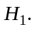 Mary will go to London this summer if both her friends Kate and Susan go.
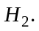 If Kate passes the English exam in May then she will go to London.
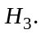 Kate was in hospital from April until July and she didn’t take the English exam.
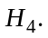This summer Susan will go to London on a business trip.
and the conclusion:  Mary will go to London this summer.
Try to simplify the initial set of clauses by applying the transformations based on Davis-Putman procedure.
Using level-saturation strategy and the deletion strategy in propositional resolution check whether the following deduction holds: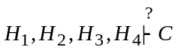

Exercise 3. Party
Hypotheses:
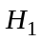. Mary will go to the party if Lucy will go and George will not go.
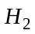. If John will go to the party then Lucy will go too.
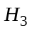. If John is in town he will go to the party.
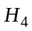. George is sick and can’t go to the party.
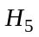. Yesterday John has returned in town from Paris.
Conclusion: : Will Mary go to the party?
Try to simplify the initial set of clauses by applying the transformations based on Davis-Putman procedure.
Using general resolution in propositional logic check whether the following deduction holds: 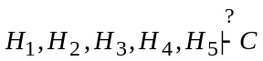

Exercise 4
Build a linear refutation from the following set of clauses:
- 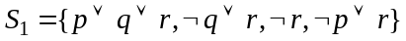;
- ;
- 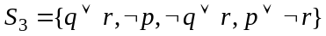;
- ;
- 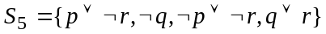;
- ;
- ;

Exercise 5
Prove the consistency of the following sets of clauses using linear resolution.
- 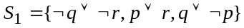
- 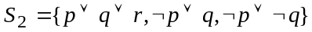
- 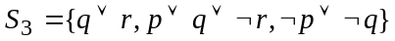
- ;
- 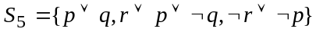;
- 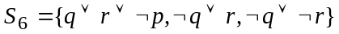
- 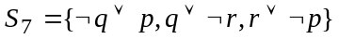
- .
Exercise 6
Using lock resolution prove the inconsistency of the following sets of clauses.
Choose two different indexings for the literals. For one indexing combine lock resolution with level-saturation strategy.
- ;
- ;
- ;
- ;
- ;
- ;
- ;
- .

Exercise 7
Check the consistency of the following sets of clauses using lock resolution.
Choose two different indexings for the literals:
- 
 
 
 
 
 

